TO SUPPLY LEFTOVER FOOD TO POOR

College Name: shri nehru maha vidyalaya college of arts and science

**College Code: bru26**

**TEAM ID: NM2025TMID20629**

**TEAM MEMBERS**

**Team Leader : JIKESHWARAN .K**

Email **:** <kamarajpraveen86@gmail.com>

**Team member 1 :** **JOSHUVA B**

**Email:**[**danieljoshuva1@gmail.com**](danieljoshuva1@gmail.com)

**Team member 2 : KUMAR R**

**Email:**[**kumarr262006@gmail.com**](kumarr262006@gmail.com)

**Team member 3: SARAVANAPERUMAL E**

**Email:**[**saravanaperumal270@gmail.com**](saravanaperumal270@gmail.com)

# INTRODUCTION

### Project Overview

. Food wastage is a major concern worldwide, while at the same time many people struggle with hunger and poverty. Supplying leftover food to the poor is an effective way to address both issues.

This initiative involves collecting surplus or unsold food from households, restaurants, hotels, functions, and events, and distributing it to underprivileged communities in need.

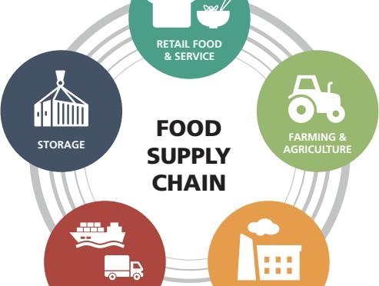

### Purpose

The purpose of supplying leftover food to the poor is to reduce hunger and malnutrition among underprivileged people by making good use of surplus food that would otherwise go to waste. It aims to:

Provide nutritious meals to those in need.

Minimize food wastage in homes, restaurants, and events. Promote social responsibility and community care.

Encourage sustainable practices that benefit both society and the environment.

# DEVELOPMENT PHASE

#### Creating Developer Account:

By using this URL **-** [**https://www.salesforce.com/form/developer-signup/?d=pb**](https://www.salesforce.com/form/developer-signup/?d=pb)

* Created objects: venue,drop of points,task, volunteer, Execution
* Complete fields and relationships

#### THEN NOW

Creat the tabs

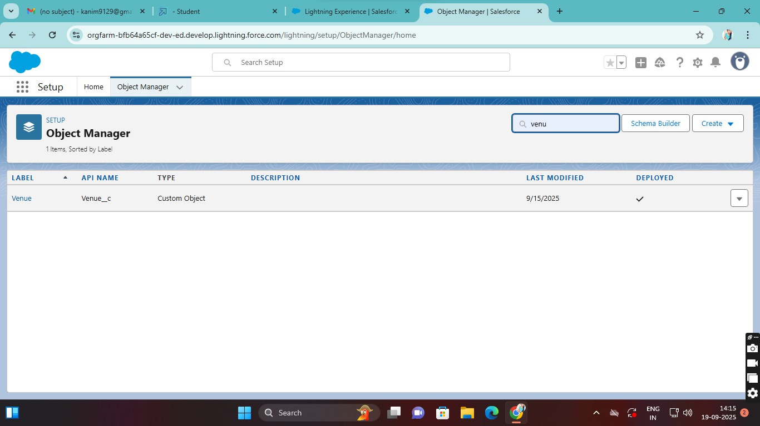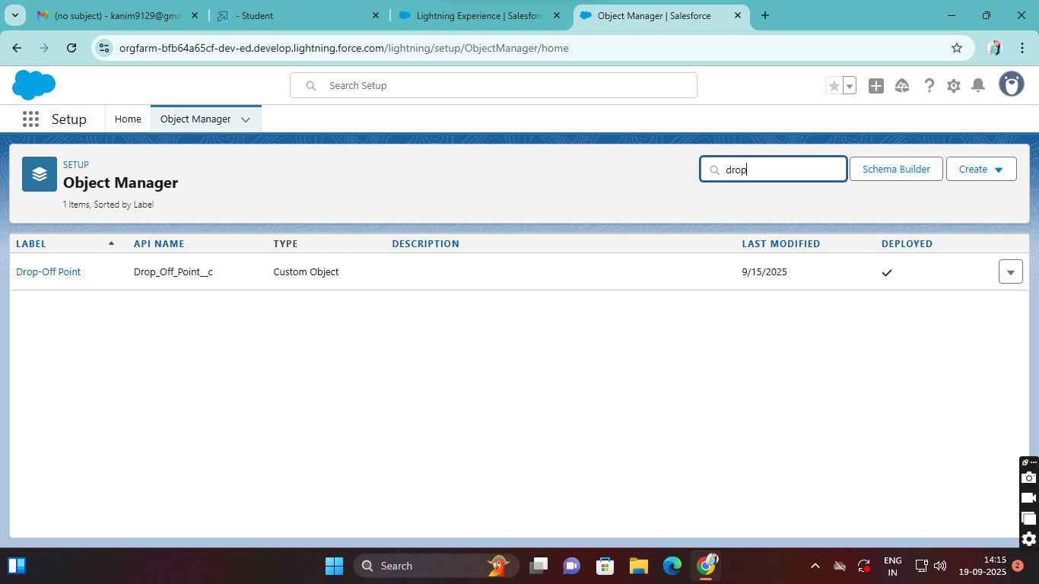

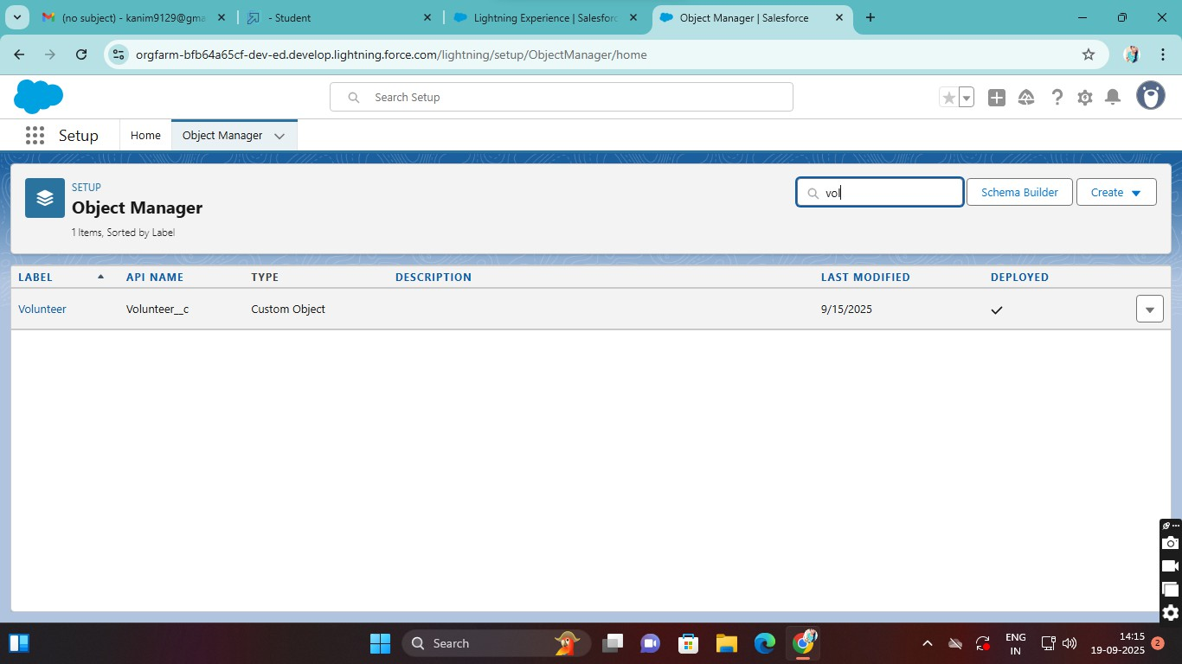

Venue

Drop-Off Point Task, Volunteer Execution Details

## The Lightning App

Then create a app “FoodConnect”

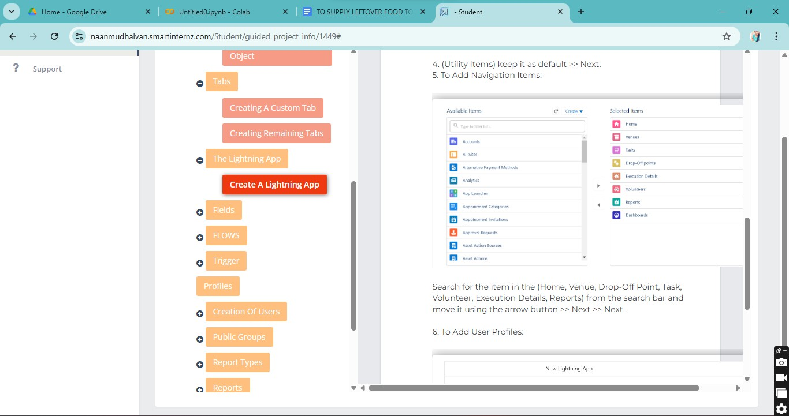

## Fields

**Creation of Lookup Relationship Field on Task Object**

* Venue
* drop of points
* Task
* Volunteer
* Execution

## FLOWS

**Create Flow to create a record in Venue object :**

* + 1. Field : Value = Contact_Email c : {!Contact_Email.value}
    2. Field : Value = Contact_Phone c : {!Contact_Phone.value}
    3. Field : Value = Name : {!Venue_Name}
    4. Field : Value = Venue_Location c : {!location}
    5. Field : Value = Location Latitude s : {!latitude}
    6. Field : Value = Location Longitude s : {!longitude}

## Trigger

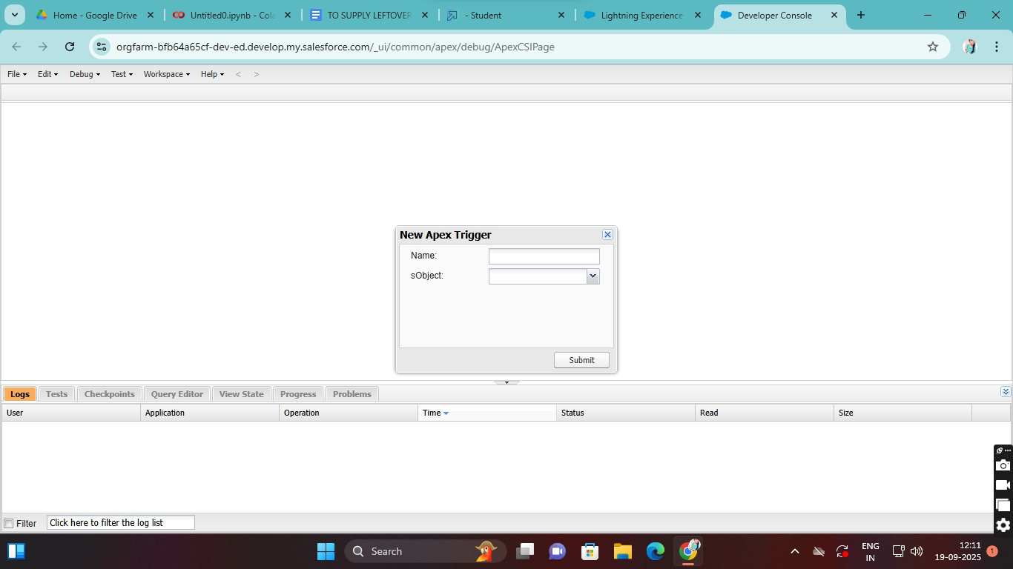

**Trigger Code**

trigger DropOffTrigger on Drop_Off_point c (before insert) { for(Drop_Off_point c Drop : Trigger.new){

Drop.Distance c = Drop.distance_calculation c;

}

}

# ADVANTAGES & DISADVANTAGES

ADVANTAGE

1. Reduces hunger: Provides meals to poor and homeless people.
2. Prevents food wastage: Surplus food is used instead of thrown away.
3. Cost-effective: Donors and NGOs can feed many without extra production costs.
4. Promotes social responsibility: Encourages kindness, sharing, and community support. 5.Environmental benefit: Less food waste means reduced pollution and lower landfill use. DISADVANTAGE
5. Food safety issues: If not handled properly, leftover food may spoil and cause illness.
6. Storage and transport: Requires proper facilities to keep food fresh during collection and distribution.
7. Irregular supply: Availability of leftover food is uncertain and may not meet demand.
8. Dependency risk: Some people might rely only on donated food instead of seeking long-term solutions.
9. Logistical challenges: Coordination between donors, NGOs, and beneficiaries can be difficult.

# CONCLUSION

Supplying leftover food to the poor is a meaningful step toward reducing hunger and preventing food wastage.

While it comes with challenges like storage, safety, and proper distribution, the benefits to society, the environment, and needy communities are far greater.

By working together—through individuals, organizations, and NGOs—leftover food can be transformed into a valuable resource that nourishes lives, promotes social responsibility, and builds a more compassionate and sustainable society.